TD Tutoriel

19.09.2018

### Exercice 4

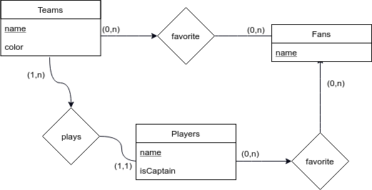

Exercice 5

key(booking) = key(customers)+key(Flight)

SSno + (number, day)

Customers(SSno, name, address, phone)

Flights(number, day, aircraft)

Booking(row, seat, #SSno, #number, #day)

Exercice 6

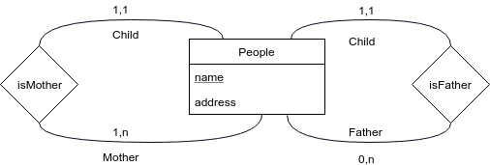

People(name, address, #motherName, #fatherName)

1. select mother Name

from People

where name=’Salim’

1. select name

from People

where fatherName=’Salim’

### Exercice 8.1

A weak entity is when the entity variable(s) is/are not enough to create a unique key.

eg : number is unique to department but not globally has each department can have this number

So it needs to use the entity to which it is connect. Each of the weak NEED to have ONE other entity. So we have a weak relationship to connect the two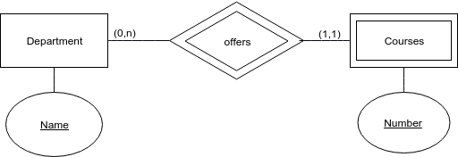

### 

### Exercice 8.2

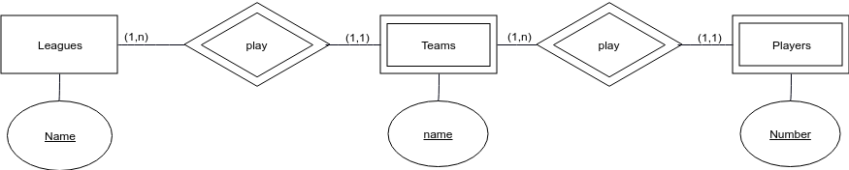

Exercice 9

